Emergency Videos for Speed Dating
Seatbelts http://www.mpi.mb.ca/en/Videos/Seatbelts.wmv

Safe Fueling http://www.mpi.mb.ca/en/Videos/SafeFueling.wmv

Blowouts http://www.mpi.mb.ca/en/Videos/BlowOuts.wmv

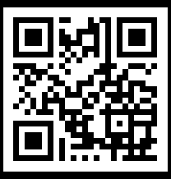

Brake Failure http://www.mpi.mb.ca/en/Videos/FaultyBrakes.wmv

Stuck Accelerator http://www.mpi.mb.ca/en/Videos/StuckAccelerator.wmv

Hydroplaning http://www.mpi.mb.ca/en/Videos/Hydroplaning.wmv

Avoid Head on Collisions http://www.mpi.mb.ca/en/Videos/HeadOnCollisions.wmv
Winter Preparations http://www.mpi.mb.ca/en/Videos/WinterPreparation.wmv
Steering System Failure http://www.mpi.mb.ca/en/Videos/SteeringSystemFailure.wmv

Unstuck Winter http://www.mpi.mb.ca/en/Videos/GettingUnstuckInWinter.wmv

