Name: ____________________________
_______ / 10 points possible
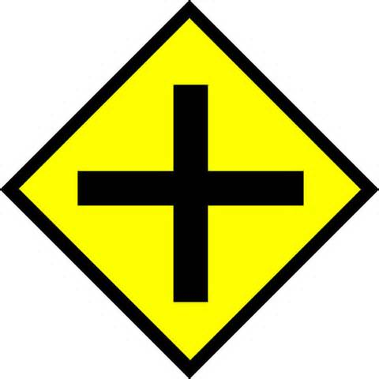
Intersection Identification
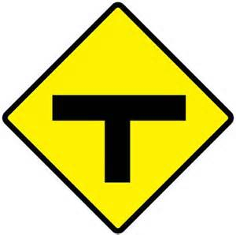
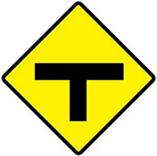
- 4 way stop
- 4 way uncontrolled
- 3 way stop
- 3 way uncontrolled
- 2 way stop / yield
- Stop / yield for me
- Thru for me
 | Far | Near | Action:  - Stop, take my turn  - Stop, wait all day  - Slow down, get ready to stop  - Keep rolling, if no conflict | “Creep and Peep” for visibility?  Yes / No
1
2
3
4
5
6
7
8
9
10
“Picky Stop”
Complete stop behind the sign, behind the stop line, behind the crosswalk.

