Name: _____________________
_____ / 31 points possible
Vehicle Quiz #1
Locate and Label:
A- VIN Number on the dashboard
B- Info sticker(s) on the driver door frame
C- Spare tire and jack
D- Muffler
E- Wiper blades
F- Gas tank fill location
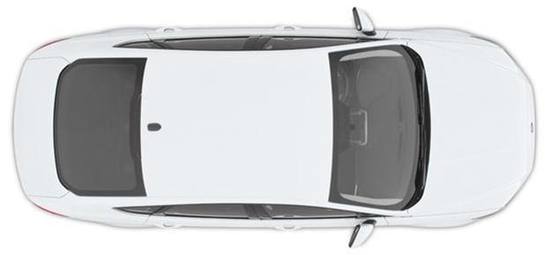
G- Struts
H- Shocks
I- Drum brakes
J- Disc brakes

Record the:
VIN number: ________________________
Front/Rear tire size: ___________________
Front tire pressure: ____________________
Rear tire pressure: _____________________
Spare tire pressure: ____________________
Vehicle weight (in lbs): __________________
Date of manufacture: ___________________

Do the back side too!

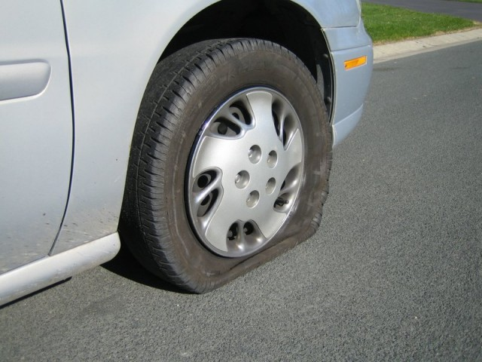
Label:
A- Drum brake
B- Disc brake
C- Strut
D- Shock
E- Air pressure gauge
F- Tread wear gauge
G- Tread wear indicator bars
H- Flat tire

1) What has more stopping power and less brake fade?
Disc brake Drum brake
2) What is usually found at the front of the car?
Disc brake Drum brake
3) What is usually found at the front of the car?
Shock Strut
4) On the bounce-back test for struts and shocks, you want:
NO bounce ONE bounce TWO bounces THREE bounces
5) When in doubt, car tires should be around… 10 PSI 20 PSI 30 PSI 40 PSI
6) The spare tire should usually be around… 40 PSI 50 PSI 60 PSI 70 PSI

