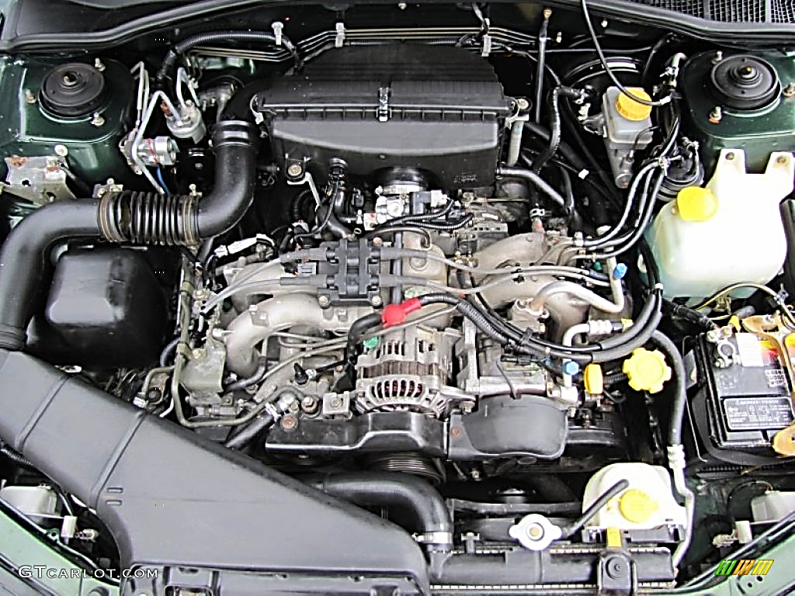
Vehicle Quiz #2 Name: _____________________

Name: _____________________
_____ / 33 points possible
Vehicle Quiz #2

Locate and label:

A- Windshield Washer Fluid 1) Do you check the oil level when the car is running? YES NO
B- Air filter
C- Battery 2) Do you check the transmission fluid level when the car is running? YES NO
D- Battery terminal(s)
E- Oil fill location 3) You check the radiator level when the car is:
F- Oil Dip Stick RUNNING, OFF but warm, OFF and cooled down
G- Transmission Fluid Dip Stick
H- Power Steering Fluid 4) What oil weight does this car take? 5W20 5W30 10W30 10W40
I- Brake Fluid
J- Radiator 5) How many cylinders is this engine? 2 3 4 5 6 7 8
K- Cooling fan(s)
L- Upper Radiator Hose 6) You can tell by looking at the:
M- Lower Radiator Hose air intake manifold(s) exhaust manifold(s) Spark plug wires all of these
N- Radiator cap
O- Radiator overflow tank 7) What is the engine identification / displacement?
P- Oil Filter
Q- Spark Plug Wires
R- Alternator
S- Alternator Belt / Serpentine Belt / AC Belt
T- AC Pump
U-Power Steering Pump
V- Fuel Filter
W- Starter
X- CV Joints
Y- Headlight replacement access
Z- Top of struts

(Some components are not easily visible or present on certain cars)

